**Kol simcha torah gazette**

**For parshas mikeitz 5784**

Volume 8 Issue 14 (Whole #372) 4 Teveth 5784/ December 16, 2023

**Printed L’illuy nishmas Nechama bas R’ Noach, a”h**

For a free subscription, please forward your request to [***keren18@juno.com***](mailto:keren18@juno.com)

***Past emails can be found on the website ShabbosStories.com under Brooklyn Torah Gazette***

**Chag Chanuka**

**Sameach 5784**

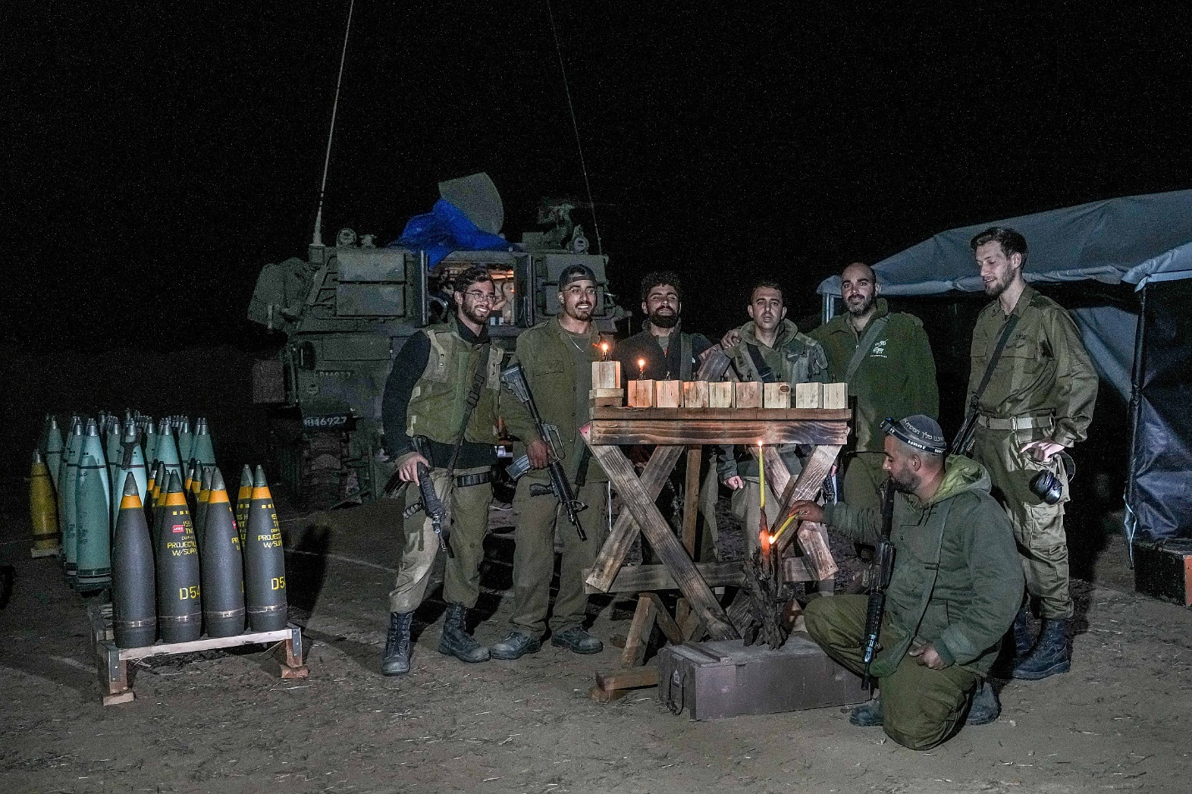

**Israeli soldiers celebrating the first night of Chanukah 5784 somewhere in Gaza.**

**Rav Avigdor Miller on**

**Lessons of the Lights**

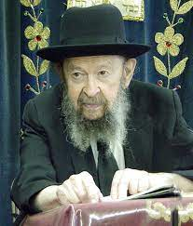

**QUESTION:** Is there any connection between lighting the *menorah* on Chanukah and the *kohanim*who light the *menorah* in the *Beis Hamikdash*?

**ANSWER:** We must know that the fact that both yield light is significant.

Because why do you have to have a *menorah*? You could have, let's say, a flower. Or you could put let's say a *peri*, an olive. Every day add another olive.   
The answer is there's something about fire, about light, that's very important.  
And light has many significances.

Light can be first of all gratitude for the light of the Torah: *Torah ohr.* And therefore, certainly the *menorah* of Chanukah shares a significance with the *menorah* of the *Beis Hamikdash*. Because the light of the Torah, that's what we are loyal to. And we thank Hashem for the Torah by means of the *menorah* that the *kohen*lights every day in the Beis Hamikdash. We thank Him for giving us the light of the Torah.

The light also signifies the light of *seichel*. *Baruch atah Hashem chonen hada'as.*How happy we are with the ability to think. It's the first *brachah*, the first *tefilah* of the weekday *bakashos.*And many people ignore that and they don't realize how important it is to be sane. *Baruch atah Hashem chonen hada'as,*that we have sanity. The ability to think is one of the biggest *matanos* of all. Without that what is life worth?

That’s also a significance of lighting the menorah in the Mikdash. We thank Hashem for giving us the light of the *seichel.*And on Chanukah too, we thank Him for the light of the *seichel* because it's only by means of our *seichel* we're able to utilize our great principles of resisting the power of the *goyim*. And therefore, these two *menorahs*certainly signify using your *seichel*.

Also, the light of the two *menorahs*speaks about the Shechinah, that the Shechinah dwells in the Am Yisroel. Every day when they lit the *menorah*, all year round, it was for the purpose of letting us know that we are always blessed that Hakadosh Baruch Hu is with us. He's constantly with us forever and ever.

And of course, on Chanukah people waited for some sign that Hakadosh Baruch Hu was with them. They won battles, all right. But maybe the battle is *koach* *basar vedam.*Where do we see the *yad Hashem*? But when they saw this *nes*of Chanukah, they saw that the Shechinah is still here with us.

There are many more significances which the *menorah* shares with the *ner Chanukah*but all together they come to teach the great lesson that we and Hakadosh Baruch Hu should always be together; and that's the *emunah*, the loyalty. He is loyal to us and we are loyal to Him.

*Reprinted from a recent email of Toras Avigdor. (Tape #E-85, November 1996.)*

***And Pharaoh called Joseph's name Tzafnat Panei'ach* (Gen. 41:45)**

As Rashi explains, Tzafnat means "hidden things," and Panei'ach means "he reveals" - i.e., Joseph was able to explain things that were hidden. Why, then, didn't Pharaoh call Joseph Panei'ach Tzafnat, which would have been more logical? To teach us that the real reason Joseph was able to interpret dreams was as a reward for concealing his righteousness. Because Joseph conducted himself in a humble and unassuming manner, "Tzafnat," he merited the gift of "Panei'ach." *(Sefat Emet)*

*Reprinted from the Parshat Mikeitz 5761/2000 edition of L’Chaim.*

**The Ability of Dreams**

**To End Our “Exile”**

**From the Teachings of the Lubavitcher Rebbe**

**Rabbi Menachem Mendel Schneerson, Zt”l**



The Torah portion of Mikeitz begins with a description of Pharaoh's dream. In last week's portion we also read about dreams: those of Joseph, and of Pharaoh's butler and baker.

**An Intrinsic Connection Between**

**Dreaming and the Concept of Exile**

It was these dreams that ultimately led to the Jewish people's exile in Egypt. Indeed, there is an intrinsic connection between dreaming and the concept of exile.

A dream is the product of the imagination. In a dream, logical contradictions make perfect sense. An elephant can pass easily through the eye of a needle.

In the same sense, the entire period of exile is only "imaginary." It may appear to a person that he really loves G-d, but what he really loves best is himself, i.e., his own physical comfort. He may be so deluded by his wants and desires that he actually transgresses the will of G-d.

Nonetheless, every Jew possesses a G-dly soul that is always whole and intact. The good deeds a Jew does are eternal. The Torah he studies and the mitzvot he performs last forever. By contrast, the negative things a Jew does are only temporary. If a Jew gives into temptation and sins, the evil doesn't last. In the end, every Jew will return to G-d.

There are some people who claim that religious observance must follow an orderly sequence, from the "lesser" mitzvot to the more "major" ones. They say that if a person hasn't reached a state of spiritual perfection, he cannot ascend to the next level. But this approach is entirely wrong. We aren't living in an "orderly" and logical world; rather, the Jewish people is in exile, the entire period of which is likened to a dream. In a dream, two opposites can co-exist peacefully. Thus, because we are only "dreaming," we must grab every opportunity that comes our way to do a mitzva, no matter how "illogical" or far removed it seems from our present level of spirituality.

**A Mitzva to Reveal this Wisdom**

In previous generations, very few people studied Chasidut, the inner, esoteric aspects of Torah. A person had to prepare himself for many years before he could even begin to approach it. In our generation, however, "it is a mitzva to reveal this wisdom." Ever since Chasidut was revealed by the Baal Shem Tov and the Alter Rebbe, the obligation to learn Chasidut falls on each and every Jew, in the same way that every Jew is obligated to study every other part of the Torah.

It is precisely now, at the very end of the exile, that we can "jump" to spiritual levels that in former times would have been beyond our reach. In exile, we are only "dreaming," and anything is possible. Regardless of our individual achievements, it is precisely this approach to Torah and mitzvot that will bring an end to the exile and bring redemption to the world.

*Reprinted from the Parshat Mikeitz 5761/2000 edition of L’Chaim. Adapted from Volume 1 of Likutei Sichot.*

**The World is Not Limited to the Laws of Nature**

Pharaoh related his dream to them but there was no one who could interpret them for Pharaoh. (41:8) Pharaoh had at his disposal the wisest men in the world. All the professional dream interpreters were called. Why was no one able to interpret Pharaoh’s dream? All the experts interpreted dreams based on the natural order of the world. That’s the only thing they understood.

The strong defeat the weak - the large consume the small. Pharaoh’s dream was the opposite. The cows of poor appearance ate the beautiful cows. The thin ears of grain swallowed up the healthy ears of grain. They couldn’t understand this. Yosef on the other hand grew up in the house of Yaakov. He saw the hand of Hashem in everything. The world is not limited to - the laws of nature. Hashem can and does make anything happen. The dreams were not so strange. The dreams could be explained. (Chochma im Nachlo by Rabbi Ze'ev Tzvi Klein) R*eprinted from the Parshat Mikeitz 5784 email of whY I Matter parsha sheet edited by R’ Yedidye Hirtenfeld for the Young Israel of Midwood in Brooklyn*

**Rabbi Berel Wein on**

**Parshat Miketz 5784**

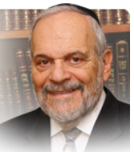

The dreamer is about to be saved by dreams, albeit not the ones that he dreamt but rather those dreamt by an unlikely stranger – the Pharaoh of Egypt himself. But dreams are dreams and often times they do not coincide with human reality. What makes Yosef so extraordinary in the eyes of Pharaoh was his ability to, so to speak, dream along with Pharaoh, interpret his dreams and translate them into practical life-saving action.

The Torah here teaches us an important lesson about life and events. Everyone has dreams and again, so to speak, they are relatively easy to come by. Nevertheless, it is what follows the dream that counts most. The rabbis and the Talmud taught us that all dreams are judged and realized according to their interpretation. By this statement, they meant to teach us that what is actually done or accomplished with the dream becomes the lasting value of the dream itself. There are many dreams that remain just that – dreams, unfulfilled reveries, good ideas and rosy predictions that somehow never come to action or fruition.

Yosef worked his entire life to make his dreams become real and true. He spared no effort to force his brothers to recognize him as their leader and to validate the dreams that he reported to them in his youth. And it was his administrative skill and foresight that made his interpretation of the dreams of the Pharaoh accurate, meaningful and providential. It is only the behavior and actions of humans after the dream that give the dream a challenging and meaningful purpose.

  The Jewish people have long dreamt and prayed for their return to the Land of Israel and for the ingathering of the exiles to their homeland. Over the past century, in unlikely fits and starts, this dream has taken on reality and substance. And, it did so, certainly, with the help and guidance of Heaven but just as importantly with the actions, achievements and sacrifices of real people and the Jewish world everywhere. This great dream lay dormant for many centuries because no one acted upon it …more of a fantasy than a possible reality.

But somehow the Jewish people awoke from the slumber of the exile and over the past century has succeeded in bringing this dream to physical reality. It is difficult to assess why it was only in the recent past, historically speaking, that the practicality of the dream began to be emphasized and exploited.

There were many great people and great Jewish communities that existed before our time who perhaps would have been deemed more worthy to give flesh and bones to the great dream of Israel. Why did they not do so and why did Jews over the last century and a half devote themselves to the realization of this dream?

That will remain one of the many mysteries of G-d that surround us on a regular basis. But one thing is clear, that the fate of dreams, national and personal, depends upon our practical, human interpretation and implementation of those dreams.

*Reprinted from the current website of rabbiwein.com*

**The Convincing Argument of Yehudah**

Then Yehudah said to Yisroel his father, ‘Send the lad with me and let us arise and go I will guarantee him: of my own hand you can demand him, if I do not bring him back to you and stand him before you, then I will have sinned to you for all time. (43:8) What did Yehuda’s statement and pledge to Yaakov really mean? Yehuda was going to do the best he could to protect Binyamin from harm without this pledge. When a person promises to do all he can in any given situation, he gives it his all. And Yehuda was no different. But as much as a person does, he could always do more if his life depended on it. There is extra hidden strength that a person can harness if he is forced to. By telling Yaakov that he will guarantee Binyamin’s safe return, and if not then he ‘will have sinned to Yaakov for all time’, Yaakov was confident that Yehuda will use this extra power - because his life does depend on it. (Shem Mishmuel) R*eprinted from the Parshat Mikeitz 5784 email of whY I Matter parsha sheet edited by R’ Yedidye Hirtenfeld for the Young Israel of Midwood in Brooklyn*

**Life Lessons From the Parshah - Miketz**

**Ephraim and Menasseh,**

**Survive and Thrive**

**By Rabbi Yehoshua B. Gordon, zal**

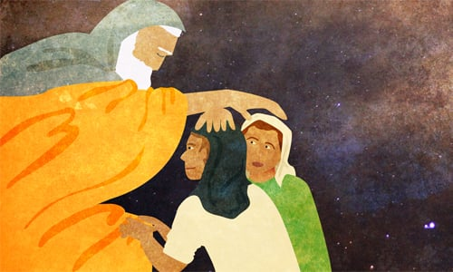

***Art by***[***Sefira Lightstone***](https://www.chabad.org/3159160)

I once encountered an extraordinary man in a hotel where I was staying as part of a Passover program. As I strolled through the grand hotel lobby, I noticed an elderly gentleman with a flowing white beard wearing full Chassidic garb.

I greeted him with the traditional “Good Yom Tov!” and in Yiddish I asked him how he was doing. He returned the greeting, and when I asked him where he was from, he told me he was from Williamsburg. Clearly, he was not talking about Williamsburg, Penn., but the Williamsburg section of Brooklyn, N.Y.

Learning that I was from Encino, Calif., he remarked, “You look like you are a Chabadnik!” I proudly confirmed, “Yes, I am; I’m proud to be a disciple of the [Lubavitcher] Rebbe and his emissary in the San Fernando Valley in California.”

“Then I would like to tell you a story about the Previous Rebbe,” he said, smiling, referring to the Rebbe’s father-in-law, the Sixth Rebbe, Rabbi Yosef Yitzchak Schneersohn.

“Before the Holocaust,” he explained, “I had a very large family. I lost my entire family to the Nazi killing machine. I survived, but I came out all alone. I was a young, broken man, lost and alone.”

“I heard that there was a very great rebbe, the Lubavitcher Rebbe, and that people would go to him and receive his blessing. So, I arranged to see the Rebbe and planned to ask for his blessing.

“I entered the Rebbe’s study, and the Rebbe asked me where I was from.”

Pausing, the man explained, “You need to understand that when the Previous Rebbe arrived in the United States in 1940, he was not physically healthy. He had suffered illness, and he didn’t speak very clearly. The Rebbe had a *gabbai*—an attendant and secretary—who was with him and would translate for him. I think his name was –”

That’s when I interjected and said, “Rabbi Simpson! My grandfather!”

The Rebbe’s attendant was Rabbi Eliyahu Simpson, my maternal grandfather. So it was actually my grandfather who asked this man the Rebbe’s question, “Where are you from?”

“I’m from Satmar,” he replied.

“What do you need?” asked the Rebbe, “What kind of blessing are you looking for?”

“*Mishpacha*,*”*I answered, “Family. I want to be able to rebuild my devastated family. I lost everyone, and I want to be able to rebuild.”

“The Rebbe gave me a tremendous blessing, telling me that I would merit to build a large family, loyal to the tenets of Judaism.”

“That’s my experience with your Rebbe and your grandfather,” he said.

“*Nu*,” I asked him, “what came of the Rebbe’s blessing?”

“Thank G‑d,” he exclaimed, beaming, “I have over 130 descendants!”

**A Family in Egypt**

The portion of Miketz continues with the riveting story of Joseph, but gives us just a few words about his descendants.

After telling us how Joseph went from jailhouse to palace, the Torah mentions that Pharaoh gave Joseph a wife, Asenath, and they had two sons together: Menasseh and Ephraim.

This story is astounding. Joseph undergoes a transformation from slave to king—the quintessential rags to riches—all within 13 short years! The fact that the [Torah](https://www.chabad.org/library/article_cdo/aid/1426382/jewish/Torah.htm) includes seemingly unrelated information about Joseph’s children suggests its significance and urges deeper exploration.

What do we know about these children? They were undoubtedly special, as demonstrated by their relationship with their grandfather, Jacob, after he arrived in Egypt. Jacob formed a profound bond with them, meeting daily to study Torah together. He considered them like his own children, telling Joseph, “… your two sons … they are mine. Ephraim and Manasseh shall be mine like Reuben and Simeon.”[1](javascript:doFootnote('1a6210507');)For this reason, Manasseh and Ephraim are counted in place of Joseph among the 12 Tribes.[2](javascript:doFootnote('2a6210507');)

While there are many commentaries that discuss the names Manasseh and Ephraim and the significance they embody, I would like to focus on a teaching from the Rebbe.

**Celebrating Survival**

As discussed [in my column on the parshah of Vayeshev](https://www.chabad.org/parshah/article_cdo/aid/6197557/jewish/Joseph-the-Happy-Lamplighter.htm), Joseph’s traumatic story—being despised by his brothers, sold as a slave, hounded by Potiphar’s wife, and locked away for 12 years—could have understandably led him to a life of depression and dysfunction. Instead, he responded to his trials with unwavering positivity. Throughout his ordeal, he constantly says, “Baruch Hashem – thank [G‑d](https://www.chabad.org/library/article_cdo/aid/433240/jewish/God.htm)! This is from G‑d! It’s all from G‑d! G‑d has helped me!”

Remarkably, Joseph emerges from this prolonged period of turmoil unscathed. Rather than wallowing in self-pity, he rises to become a king in Egypt. Which begs the question: How can a person maintain such resilience?

The answer lies in the strength and resilience derived from G‑d. Joseph not only knew this truth, but lived by it, firmly believing that there are no accidents, only a Divine plan.

This understanding is reflected in the name Joseph gave his eldest son, Manasseh, which means “G‑d has caused me to forget all my toil and all my father’s house.”[3](javascript:doFootnote('3a6210507');) It doesn’t mean Joseph completely erased the memories of his experiences, but that G‑d allowed him to set aside all his troubles and all his suffering.

Consider how many incredible stories of strength and resilience came out of the Holocaust. Despite facing unimaginable horrors, many survivors managed not only to function daily, but also to become extraordinary individuals.

Joseph embodies this idea. Despite the challenges, he declares, “Thank G‑d, I survived. G‑d allowed me to set aside and overcome my trauma.” To commemorate this survival, he named his son Manasseh.

**Moving Beyond Survival**

The Rebbe, however, emphasizes that mere survival is insufficient. We must not only survive; we must thrive!

Many Holocaust survivors, after overcoming their trauma, immediately married and brought new children into the world. They started businesses and established communities. For many, if not most, it took years before they could talk about their experiences. But they *thrived*.

Joseph recognized this truth, which is why he named his second son Ephraim, meaning “G‑d has made me fruitful in the land of my affliction.”[4](javascript:doFootnote('4a6210507');) Said Joseph, “Not only did I survive – Manasseh – but I thrived – Ephraim. Not only did I survive my trauma, but I am at the top of my game. I am as productive as I could be and then some! I didn’t just survive and find a nice nine-to-five job; I became the king! I run the country!”

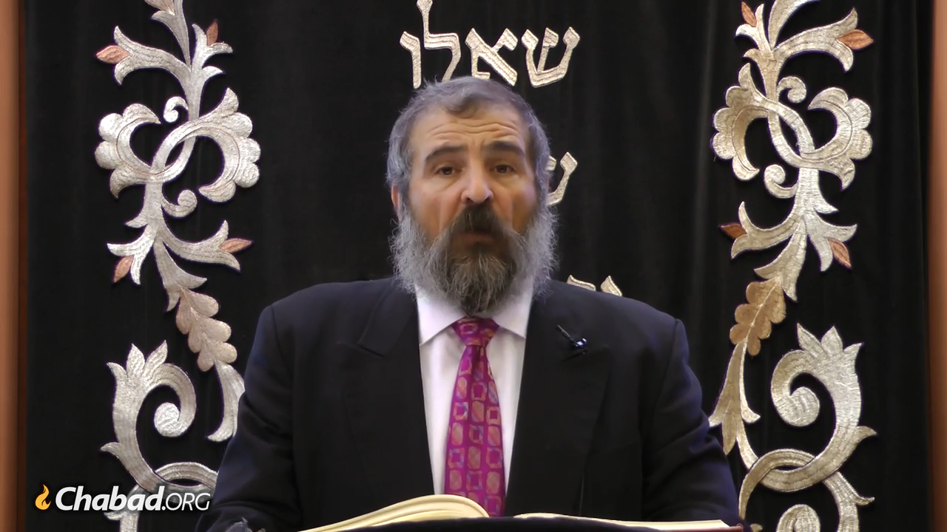

**Rabbi Yehoshua B. Gordon, of blessed memory**

Looking ahead to the portion of Vayechi, Jacob blesses his grandsons, Manasseh and Ephraim, with the words, “May the angel who redeemed me from all harm bless the youths, and may they be called by my name and the name of my fathers, Abraham and Isaac, and may they multiply abundantly like fish, in the midst of the land.”[5](javascript:doFootnote('5a6210507');)

Before bestowing the blessing, Jacob placed his hands on his grandsons’ heads in a peculiar manner, crisscrossing them. He placed his stronger and more dynamic right hand – the hand of blessing – on the head of Ephraim, the younger son, and his left hand on Manasseh. Why? Because Jacob agreed with Joseph: survival is important, but for a Jew, thriving—symbolized by Ephraim—is paramount.

This reinforces the Rebbe’s message: while surviving our trials and tribulations is important, it is not enough. We must thrive. We must grow. This is a key takeaway from the Joseph story that we must strive to incorporate into our daily lives.

Wishing everyone a happy Chanukah. Let’s get out there and thrive!

*Reprinted from the Parshat Mikeitz 5784 website of Chabad.Org*

**The Dangers of Living a**

**Life of Excess Luxury**

**By Daniel Keren**

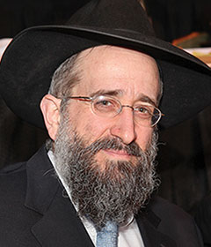

**Rabbi Yisroel Reisman**

One of the featured speakers at the recent Thanksgiving Day Yarchei Kallah Event sponsored by Hakhel at the Agudath Israel of Madison in Flatbush was Rabbi Yisroel Reisman. Hakhel is a Flatbush-based organization dedicated to promoting Torah-true values to Jews in the New York Metropolitan region. In recent legal day Hakhel Yarchei events, Rabbi Reisman, mora d’asra of the host shul has been giving shiurim, lectures on Sefer Micha that is part of Sefer Trei Asar (the Book of Twelve Minor Prophets).

The focus of his Thanksgiving Day lecture was on Perek Beis (Chapter 2). It begins with the Navi (Prophet Micha) talking about those who plan their acts of premeditated evil because of their jealousy of other people’s fields and homes and their dishonest schemes to find ways to acquire them illegally.

*Woe to those who plot iniquity and work evil in their beds; when the morning becomes light they perform it, for their hand has the power. And they covet fields, and they rob; and houses, and they take; and they oppress a man and his house, and a man and his heritage. Therefore, so said, the L-rd: Behold! I plot evil against this family, from which you shall not remove your necks, nor shall you walk erect, for it is a time of evil* (Micha 2:1-3)

**G-d Has His Plans to Punish the Wicked**

Rabbi Reisman pointed out that the Navi promises that those wicked may make their plans, but G-d will make His plans to punish them.

Who is worse, those who instinctively steal from others when the opportunity arises or those who specifically make plans to take from others? The answer according to the Prophet Micha is that those who plan and think in their heart how to steal from others are worse.

The person who steals on impulse is guilty of one aveira, sin; whereas the one who lusts for the property of another and plots how to get that item from his fellow Jew is guilty of three sins – (1) lusting, (2) planning to acquire and (3) actually stealing the other person’s property.

**When Desiring Something is Not a Sin**

The Steipler (Rabbi Yaakov Yisroel Kanievsky, 1899-1985) writes that the aveira is wanting the possession that your neighbor has. If he has a delicious pastry and you also would like to have a similar pastry, that is not a sin.

The challenge in life, Rabbi Reisman said, is to realize that not everything that someone else has is something that you should desire to possess. This is an attitude of gaiva, arrogance that everything [that exists] is something that you deserve to have. Hashem wants you to overcome and eliminate this desire from your heart. The Prophet Micha speaks harshly of those who plan to rob from others. Their punishment is that others will steal from them and they will be perplexed.

The Chavos Yair (a 17th century Gernam posek – Rabbi Yair Chaim Bacharach, 1639-1702) was once asked a Sheilah (halachic question) from a group of Jews who were in the same business. They had made an agreement with each other that if any dispute should arise among the group, they would go to a rav to arbitrate.

The only problem is that when you do so, it is customary to pay a fee to the rav for his services. Someone advised the group that all they have to do is just agree amongst themselves that they should just agree to be dishonest with each other and thereby eliminate the costly need to pay a rav for every dispute. However, Rav Pam replied that such a solution is worse than the actual sin that one would commit if doing the same action on impulse. How can one knowingly do things that we know are dishonest?

**Overcoming One’s Desire to Eat Chazer**

The Rambam says that Chazal, our Sages of blessed memory teach us that those prohibitions that are chukim (decrees without any seeming logical explanations) such as not eating chazer (pig meat), one should say to oneself, “I would love to eat it, but what can I do since Hashem has prohibited it.

But those things that are clearly understood to be forbidden (i.e., the prohibition against killing or stealing from others) should not even be a desire for one to say, “I would like to do it, but what can I do since Hashem has prohibited it.”

The biggest challenge for many in our community today is to avoid living a luxurious lifestyle and flaunt it before others. This often forces others who view such a lifestyle to unfortunately contemplate doing financial deeds that are clearly dishonest in order to obtain the money to enjoy that same type of non-necessary luxuries that unfortunately many now think are necessities.

**Placing a Dangerous Stumbling**

**Block Before One’s Children**

Rabbi Reisman said that this is not to say that those who are wealthy cannot enjoy a lifestyle that they can pay for with honest money. However, such people should contemplate just what kind of obstacles that they are placing before their own children who might not be able to afford such an extravagant lifestyle and therefore, G-d forbid be tempted to scheme illicit ways to obtain the money required for a lifestyle they became addicted to while growing up in their parent’s homes.

The Navi Micha prophesizes that Hakodesh Baruch Hu is going to take away from those people who think that they can justify their act of taking illicitly those things which they erroneously believe they need and are entitled to, and this will destroy their improper gaiva.

*Reprinted from the December 7, 2023 issue of The Flatbush Jewish Journal.*